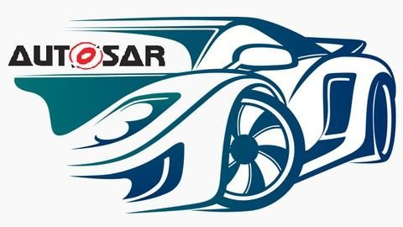



Automotive Open System Architecture

Table of Contents

Acronyms and Abbreviations of AUTOSAR 4

AUTOSAR 5

Classic AUTOSAR Platform 5

Why AUTOSAR 5

Classic AUTOSAR main working topics 5

1. AUTOSAR Architecture 5

1. Application layer 6

2. Runtime environment (RTE) 7

3. Basic software (BSW) 7

3.1 Services layer 7

3.2 ECU Abstraction layer 8

3.3 Microcontroller Abstraction layer 8

2. AUTOSAR Methodology 9

1. System Extract 10

2. ECU Extract 10

3. PDF 10

4. BSW MD 11

5. ECU Discerption 12

3. AUTOSAR Application Interfaces 12

1. AUTOSAR Interface 13

2. Standardized AUTOSAR Interface 14

3. Standardized Interface 14

Adaptive AUTOSAR Platform 15

Adaptive AUTOSAR Architecture 15

1. Application layer 16

2. AUTOSAR Runtime for Adaptive Application (ARA) 16

3. Functional Clusters 17

4. Operative System 17

5. Machine 17

Communication between AUTOSAR Platforms 17

Classic AUTOSAR VS Adaptive AUTOSAR 18

Applications of AUTOSAR 19

Advantages and Disadvantages of AUTOSAR 19

Definitions of AUTOSAR Keywords 20

# Acronyms and Abbreviations of AUTOSAR

* **OEM** – Original Equipment Manufacturing
* **TIER 1** – Direct Suppliers to an OEM.
* **BSW** – Basic Software
* **RTE** – Run Time Environment
* **MCAL** – Microcontroller Abstraction Layer
* **SWS** – Software Component
* **CDD** – Complex Device Driver
* **SOA** – Service Oriented Architecture
* **ECU** – Electronic Control Unit
* **ARA** – AUTOSAR Runtime Adaptive Environment
* **POSIX** – Portable Operating System Interface
* **OSEK** – Operating System Embedded Kernel
* **CAN** – Control Area Network
* **API** – Abstract Programming Interface

# AUTOSAR

The AUTOSAR standard defines variations of the software architecture called as AUTOSAR platforms.

# Classic AUTOSAR Platform

The **AUTOSAR** or **Automotive Open System Architecture** was developed to create a common standardized software architecture for designing automotive electronic control units (ECUs).

AUTOSAR (Automotive Open System Architecture) was founded in **2004** by a consortium of leading automotive manufacturers (OEMs), suppliers, and service providers from the electronics, semiconductor, and software industries.

Improve the **reusability** and **exchangeability** of software modules between the OEMs and Suppliers.

# Why AUTOSAR

# Classic AUTOSAR main working topics

There are 3 main working topics in AUTOSAR.

# 1. AUTOSAR Architecture

* Architecture providers a structured platform for hardware independent software application with the help of AUTOSAR basic software stack.
* layered architecture, that support the realization of functional requirement into an ECU.
* Abstract, hardware components from application layer. **Block diagram of AUTOSAR architecture:**

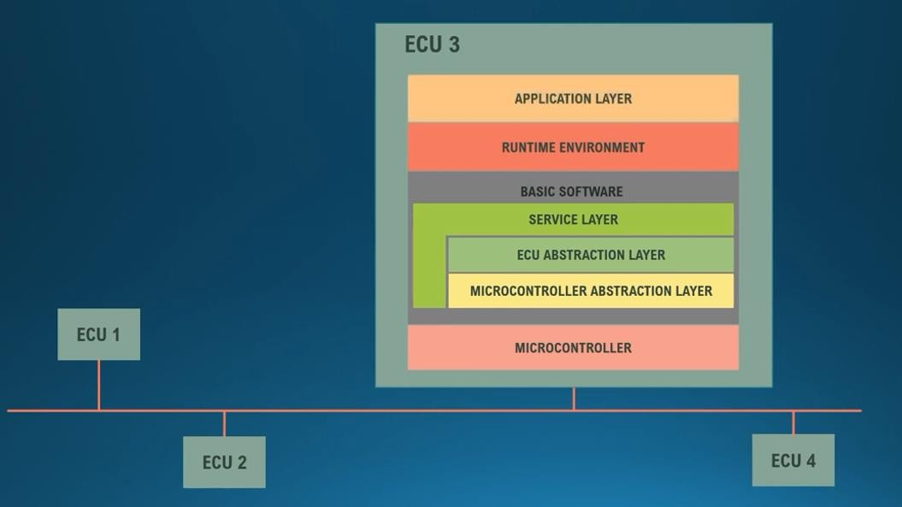

**The AUTOSAR specifies a three-layer architecture, which are categorized into following modules:**

## Application layer

* The **Application layer** is the first layer of the AUTOSAR software architecture and support custom functionalities implementation.
* The AUTOSAR application layer includes various application specific software components that are designed to execute specific set of tasks, as per the use-cases.

**Block diagram of application layer:**

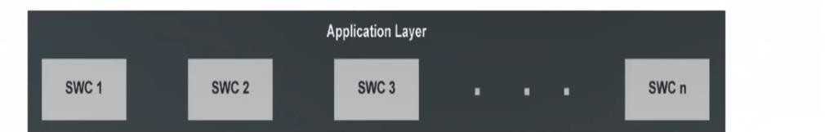

Note: To explore the more about application layer click on below link.

[https://www.embitel.com/blog/embedded-blog/decoding-the-component-concept-of-the-](https://www.embitel.com/blog/embedded-blog/decoding-the-component-concept-of-the-application-layer-in-autosar) [application-layer-in-AUTOSAR](https://www.embitel.com/blog/embedded-blog/decoding-the-component-concept-of-the-application-layer-in-autosar)

## Runtime environment (RTE)

* The **RTE** layer acts as a middleware between the AUTOSAR application layer and the lower layers. Basically, the RTE layer manages the inter- and intra-ECU communication between the **Application layer** components as well as the **BSW layer** components.
* Provides the communication and scheduling services to application software’s.
* The main purpose of RTE is to make application software independent of ECU. **Block diagram of RTE layer:**



## Basic software (BSW)

* Responsible for **managing hardware resources** and **providing common services for application software.**

**Block diagram of basic software layer:**

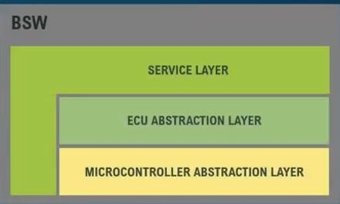

The AUTOSAR Basic Software is further divided in the layers:

### 3.1 Services layer

* The **service layer** is the top most layer of the AUTOSAR Basic Software Architecture.
* Provides background services for applications, RTE, BSW modules.
* The main work of the services layer is to provide services from the application layer to the microcontroller layer.
* The service layer constitutes an operating system, which runs from the application layer to the microcontroller layer. The OS has an interface between the microcontroller and the application layer and can schedule application tasks.
* **The service layer in BSW is responsible for services like network services, memory services, diagnostics service, communication service, ECU state management, and more.**

**Block diagram of service layer in BSW:**

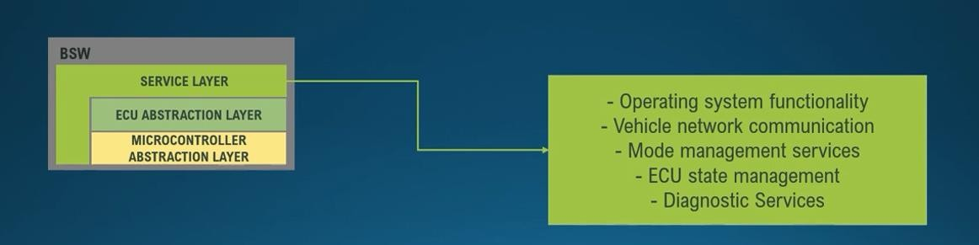

### 3.2 ECU Abstraction layer

* The **ECU abstraction layer** interface the drive of the micro controller abstraction layer. it also contains driver for external devices.
* It offers an API for access to peripherals and devices regardless of their location (Microcontroller internal/external) and their connection to the microcontroller (port pins and type of interface).
* **This layer and its drivers are independent of the microcontroller and dependent on the ECU hardware and provide access to all the peripherals and devices of ECU, which supports the functionalities like communication, memory, I/O, etc**.
* ECU abstraction layer makes the higher levels independent of ECU hardware.
* ECU abstraction layer provides the uniform to all functionalities of ECU. Block diagram of ECU abstraction layer in BSW.

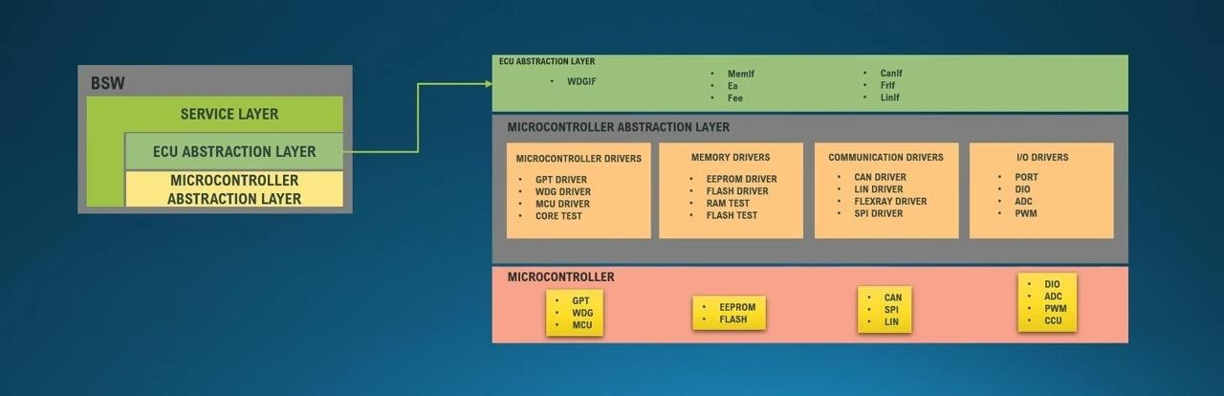

### 3.3 Microcontroller Abstraction layer

* The **Microcontroller Abstraction Layer** is the lowest software layer of the Basic Software. It contains internal drivers, which are software modules with direct access to the µC and internal peripherals.
* **Provides direct access to all on-chip microcontroller peripheral and external devices which are mapped to memory.**
* The Microcontroller Abstraction Layer makes the application and basic software layer independent of the underlying hardware platform.
* Every microcontroller has its own MCAL derivers. **Block diagram of MCAL in BSW:**

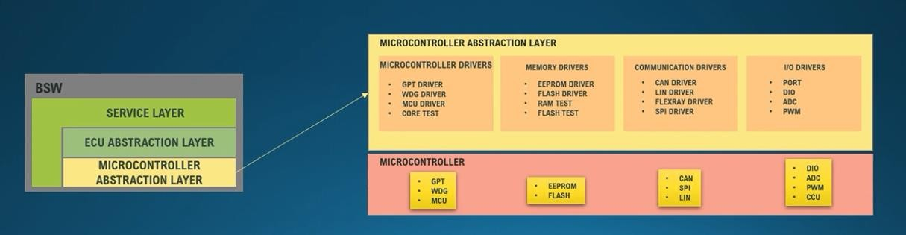

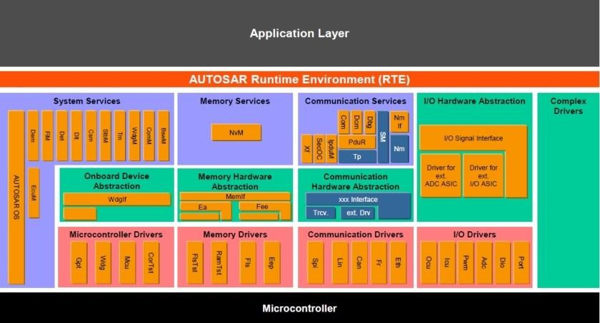Detailed Diagram of AUTOSAR Layered Architecture

# 2. AUTOSAR Methodology

AUTOSAR methodology divided into 5 types below here explained in detail:

## System Extract

The combination of all ECU information’s is called as “**system extract**”.

## ECU Extract

ECU extract file contain the 1 ECU information and ECU contains the Frame details, PDU details, received frame details, transmit frame details, Count of signals, Length of the signal, PDU length, Frame length this all details will available inside ECU extract file.

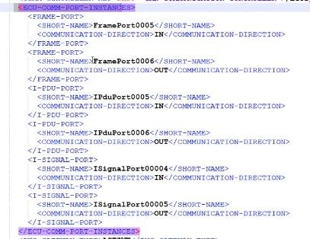

## PDF

PDF file nothing but a **Parameter Definition File**. PDF Is the template for this configuration parameters which is nothing, but a declaration of containers and parameters will be there inside the PDF ARXML files. All the modules information will be provided by the AUTOSAR documentation. Based on the information will configured accordingly.

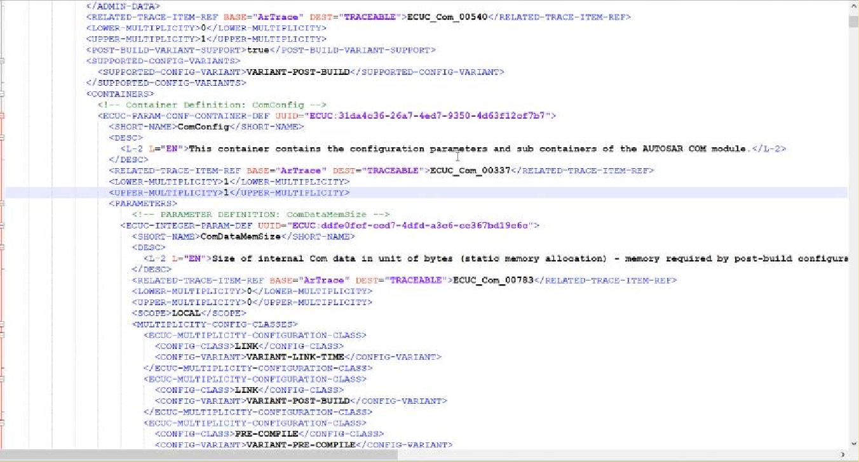

## BSW MD

BSW MD file nothing but a it’s contains the Vender ID **(vender id is nothing but, in our implementation, a particular module will change any values inside the PDF’s that PDF’s called as a Vender ID**), Static and Dynamic code versions, AUTOSAR version, Code Generated version, in a module how many API’s are available and what is main function derived each module. So, all this details information available inside the BSW MD file.

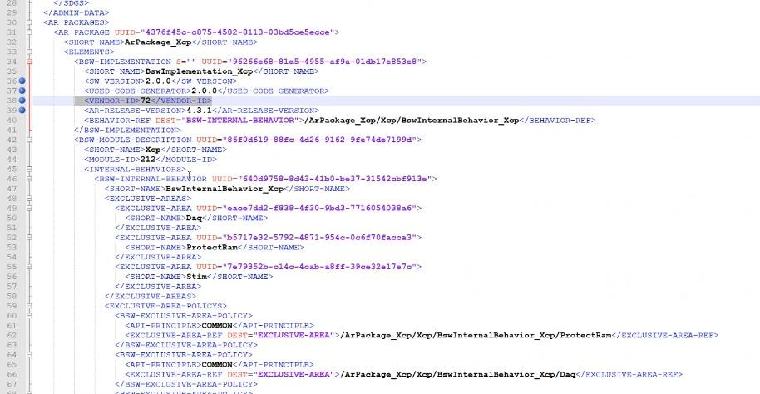

## ECU Discerption

ECU discerption is nothing but a if you provide the actual values of the containers **or** parameters this information will be there in ECU Discerption file. After compilation of this process will get **.h** and **.C** or **C++** dynamic files.

The process of conversion from the **System Extract** to **ECU Discerption** is called as a “**AUTOSAR METHODOLOGY**”.

# 3. AUTOSAR Application Interfaces

The **AUTOSAR interface** will be helpful to make a communication between the AUTOSAR software components.

**AUTOSAR Interface block diagram:**

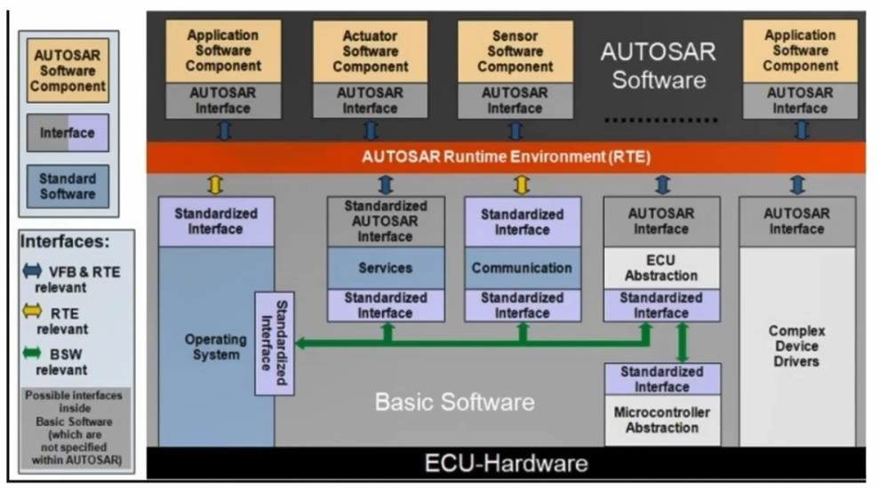

The AUTOSAR interface of the basic software are grouped in 3 categories.

## AUTOSAR Interface

* **AUTOSAR interface** will be used in the Application layer.
* The main role of AUTOSAR interface to make a communication of between the software components at the same time it will make a communication between the BSW as well.
* The AUTOSAR interface will communicate via RTE.
* AUTOSAR Interfaces of software components are defined by ports and port interfaces.
* The SWS interact with other components only through AUTOSAR interfaces.
* Relevant of modeling of software components.
* Definition of information exchanged between the software components. **AUTOSAR Interface block diagram:**

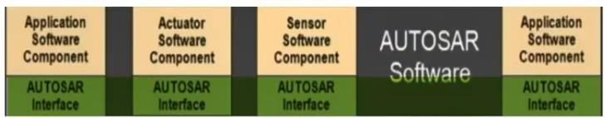

## Standardized AUTOSAR Interface

* The **Standardized AUTOSAR Interface** will be used in the system services.
* This can be called via RTE from the Application layer
* This typically used for services in BSW layer.
* AUTOSAR services interact with other software components through a standardized AUTOSAR interface.
* Syntax and semantics are standardized (C-API).
* Used to define AUTOSAR services.

EX:

Service Name: Dem_setEventStatus

Syntax: Std_ReturnType Dem_setEventStatus(Dem_EventIdType EventId, Dem_EventStatusType EventStatus)

**Standardized AUTOSAR Interface block diagram:**

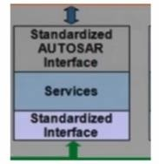

## Standardized Interface

* The Standardized Interface will not use for software components.
* It will used within the BSW layer.
* Only C-API is Standardized.
* **Standardized Interface** are typically used between the software modules which are always on the same ECU.
* Standardized Interface cannot use communication between the ECU to ECU. **Standardized Interface block diagram:**

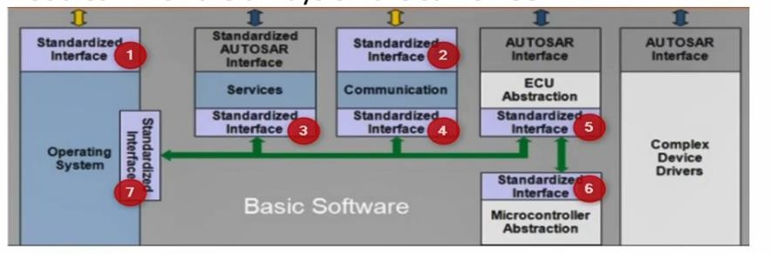

# Adaptive AUTOSAR Platform

* The **AUTOSAR Adaptive platform** is a standardized architecture for high-performance computing ECUs to build safety systems such as highly driving, autonomous systems, more powerful and more flexible E/E architectures in the vehicle. It was developed in 2018.
* The big advantage is Adaptive ECUs make it possible to update applications over a vehicle’s entire life cycle and add new software functions at a later time.

# Adaptive AUTOSAR Architecture

The Adaptive Platform is a distributed computing and service-oriented architecture (SOA).

The platform provides high-performance computing, message-based communication mechanisms,

and flexible software configuration for supporting applications, such as automated driving and infotainment systems.

**Adaptive AUTOSAR Architecture Block Diagram:**

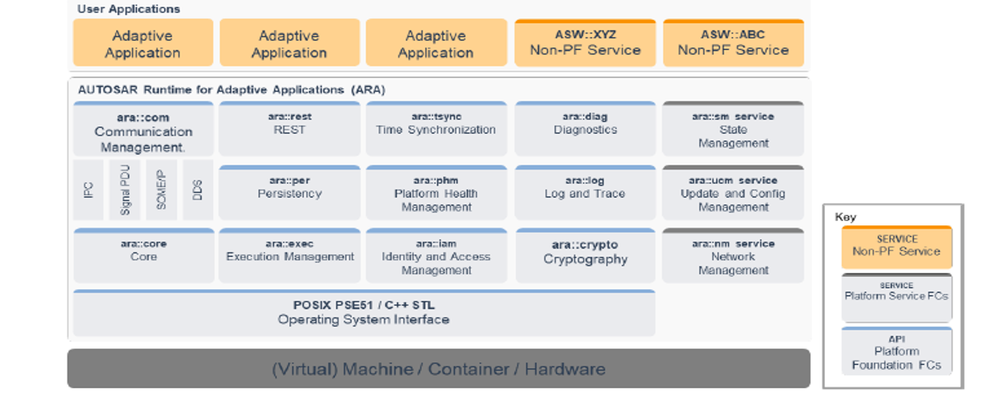

**The AUTOSAR specifies a three-layer architecture, which are categorized into following modules:**

## **Application layer**

* **The adaptive applications can be integrated at runtime. This implies that different software can be developed and distributed for an ECU, completely independent of each other.** At the heart of an AUTOSAR adaptive platform, there is an POSIX operating system and each adaptive application is implemented as a process in this OS.
* In AUTOSAR Adaptive platform, Applications are not totally bounded by a static scheduling and memory management but are free to allocate memory on their current need and break down their tasks to object-oriented programming.
* The Execution Manager module is an element of the architecture responsible for startup and stopping the AUTOSAR Adaptive Applications, and responsible for providing the necessary resources during the execution period of the applications.
* To ensure the communication between local applications and applications on other ECUs including the interaction with the Adaptive platform services, a middleware protocols must be defined. The most noticeable changes in the use of AUTOSAR Adaptive are the universal use of Ethernet based communication systems.
* In the Adaptive platform, the applications utilize the “AUTOSAR Runtime for Adaptive Applications,” also known as ARA. This runtime environment gives users standardized interfaces to efficiently integrate different applications into the system.
* The Adaptive platform now offers the option of removing, updating, or adding individual applications at run-time.

## **AUTOSAR Runtime for Adaptive Application (ARA)**

* **One of the core features of this adaptive platform is called AUTOSAR Runtime for Adaptive Applications (ARA). ARA gives users all the interfaces and infrastructure needed to communicate and execute adaptive applications into the system and allows data exchange between ECUs regardless of their internal architectures.** In addition, this runtime offers direct access to the operating system functions known as the “Minimum Real time system Profile” (PSE51).
* The module operating system interface based on a subset of POSIX is responsible for run-time resource management such as signals, timer and thread handling for all adaptive applications and functional clusters that establish the platform.
* **ARA offers mechanisms for ECU-internal and inter-network communications as well as access to basic services such as diagnostics and network management. The adaptive AUTOSAR applications are formed in software components that communicate via services.** These services may be requested or provided. In addition, the application programmer can directly access a subset of operating system functions. In terms of communication, the AUTOSAR Adaptive defines a new feature called ara::com. ara::com is a standard C++ API based on SOA more specifically based on SOME/IP.
* **ARA works in a different way with service or client based dynamically to improve the responsiveness, reliability and portability feature.**

## **Functional Clusters**

* **The software of the Adaptive Foundation and Adaptive Services is presented in the form of functional clusters.** Simply put, a functional cluster is a set of requirements grouped by the aspect they refer to. These functional clusters are, in a manner, similar to the concept of the basic software (BSW) in the Classic Platform. **Their main purpose is to offer functionalities in the form of services to the application.** However, being part of the new Adaptive Platform, and in contrast to the BSW, the new functional clusters are now processes, which can be single-threaded and multithreaded. Another key feature is the dynamicity vs. the traditional static nature of the BSW. Just as in the Classic AUTOSAR, there are needs for non-volatile storage, communication, and diagnostics, to name a few, which are taken care of by non-volatile memory (NVM), Com, Diagnostic Communications Manager (DCM) and Diagnostic Event Manager (DEM). These needs are catered to in the Adaptive AUTOSAR through functional clusters, such as Persistency, Communication Management, and Diagnostic Management. Although similar in purpose, they differ in nature. For instance, Persistency is based on key-value and stream storages, and Communication Management drops the signal-based approach in favor of a service-oriented strategy.

## **Operative System**

* The module operating system interface based on a subset of POSIX is responsible for run-time resource management such as signals, timer and thread handling for all adaptive applications and functional clusters that establish the platform.
* It is one of the pre-requisites of using complex processors and offers developers the necessary building blocks to create high-performance automotive applications to run on different systems without modification.
* The POSIX standards cover a wide range of functionalities, including file I/O, process management, thread management, inter-process communication, and more. It was originally developed by the IEEE (Institute of Electrical and Electronics Engineers) as IEEE Std 1003.

## **Machine**

The new term, “Machine,” given by Adaptive AUTOSAR is, in simple terms, the entity where the software runs. It is understood that this Machine can be of virtual nature. The actual hardware can in turn host one or multiple Machines.

# Communication between AUTOSAR Platforms

How to communicate between Adaptive and Classic ECUs is a mandatory question. In such a scenario, the ECUs which are interconnected over Ethernet use service-oriented communication over SOME/IP. In this example, the AUTOSAR Classic ECU1 is connected to multiple bus systems to which other ECUs are connected (Fig.5). ECU1 operates as a gateway in this configuration and it’s responsible for transferring the message signals from the bus side into a service so that they can be accessed directly by the AUTOSAR Adaptive platform. The communications layout is a fixed component of the design of AUTOSAR ECUs, whether it is a Classic or Adaptive platform. Because the configuration format is different for the two platforms, it is necessary to map the service configuration in the form of a conversion. The situation is somewhat more multifaceted for communicating with an AUTOSAR Classic ECU whose operation is exclusively signal based. In this scenario, the ECU1 is designed as a signal gateway, and it converts message signals directly into UDP frames (“Specification of UDP Network Management,” n.d.) on Ethernet. The AUTOSAR Adaptive ECU now converts signals from the UDP frame to a service that is available within ECU2.

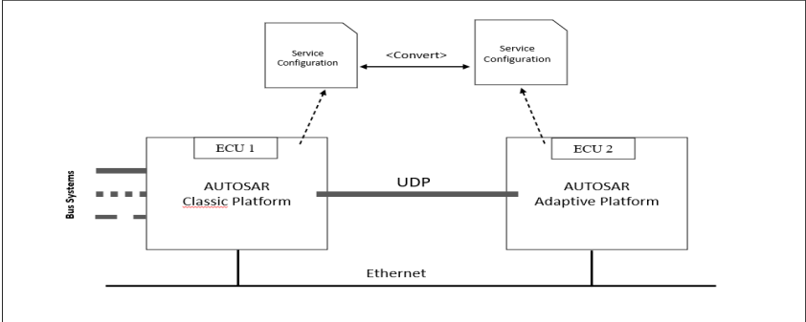

# Classic AUTOSAR VS Adaptive AUTOSAR

**Classic:**

* First released on 2014.
* It works on Signal based communication like CAN, LIN, MOST and FlexRay etc.
* Implementation of deeply embedded functionalities.
* Software update at run time is not possible, communication between the software components are hard-wired.
* classic AUTOSAR are written in C Language.
* The software executes from ROM memory.
* Classic AUTOSAR is based on OSEK operating system.
* Update in a Classic Platform implies replacement of the entire ECU code.
* does support such multicore processors in latest version.
* It is configured in a static manner.
* It uses MPU that works on the same address space for application software with early binding.
* It supports up to ASIL-D standard.
* Examples of future systems: Engine Control, Braking systems, Airbag Control Unit, sensor and actuator interfacing etc.

**Adaptive:**

* First released on 2018.
* It works on Service based communication like SOMEIP and Ethernet.
* Implementation of high-performance functionalities.
* Adaptive AUTOSAR RTE is independent of the applications and hence, Over-The-Air update is possible.
* Adaptive AUTOSAR are written in C++ Language
* The software executes on RAM memory.
* Adaptive AUTOSAR is based on POSIX operating system.
* Adaptive platforms provide the options to remove/update individual applications in an ECU.
* does support such multicore processors.
* It is configured in a Dynamically manner.
* It supports MMU that works on virtual address space for each application with late binding.
* It supports up to ASIL-B standard
* Examples of future systems: Over-The-Air updates (OTA), Sensor fusion Data processing, Persistence, Dynamic choosing of application packages over run-time of vehicle, ADAS, AD, AI, ML and complex ECU development etc.

# Applications of AUTOSAR

* Sensors like LIDAR and RADAR
* Electrification
* ADAS Functions with a Camera
* v2x
* Map Updates
* Automotive Apps
* Over-the-Air (OTA) Updates
* ECU Integration and Compatibility
* ECU Software Development

# Advantages and Disadvantages of AUTOSAR

**Advantages:**

* Reusability of software component
* Software code can be reused
* Design flexibility is more
* Cost and development time will be reduced

**Disadvantages:**

* Complexity
* Initial Investment
* Learning Curve

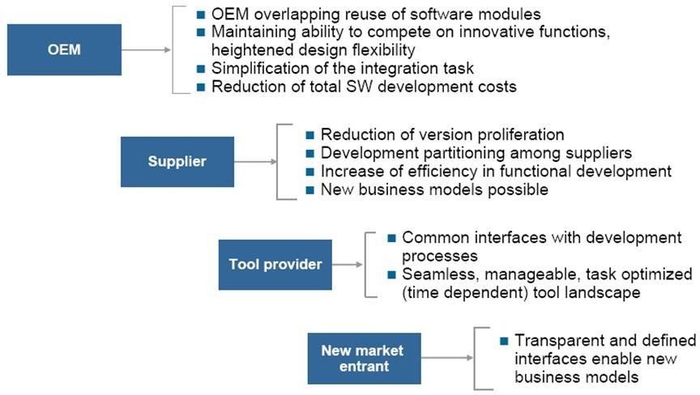

# Definitions of AUTOSAR Keywords

**POSIX:**

* It is one of the pre-requisites of using complex processors and offers developers the necessary building blocks to create high-performance automotive applications to run on different systems without modification.
* The POSIX standards cover a wide range of functionalities, including file I/O, process management, thread management, inter-process communication, and more. It was originally developed by the IEEE (Institute of Electrical and Electronics Engineers) as IEEE Std 1003.

**OSEK:**

* The OSEK (“**Open Systems and their Interfaces for the Electronics in Motor Vehicles** “) is a standards body that has produced specifications for an embedded operating system, a communications stack, and a network management protocol for automotive embedded systems. It has also produced other related specifications. OSEK was designed to provide a standard software architecture for the various electronic control units (ECUs) throughout a car.
* 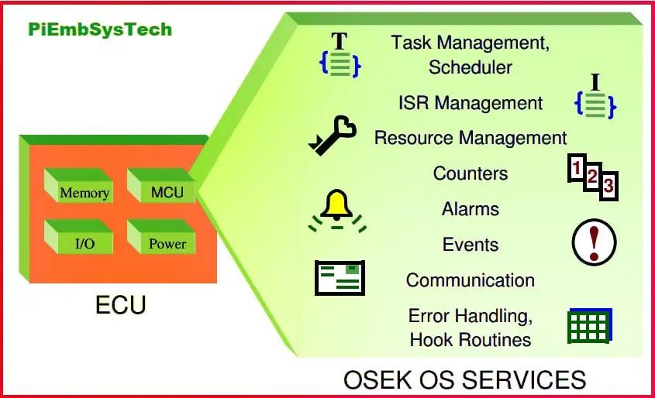The OSEK was founded in 1993 by a German automotive company consortium (BMW, Robert Bosch GmbH, DaimlerChrysler, Opel, Siemens, and Volkswagen Group) and the University of Karlsruhe. In 1994, the French car manufacturers Renault and PSA Peugeot Citroën, which had a similar project called VDX (Vehicle Distributed executive), joined the consortium. Therefore, the official name is OSEK/VDX.

**SOA:**

* The service-oriented communication is a flexible and efficient way to interconnect systems and their subscribers based on applications which provide services on the communication network.
* It is the SOA that allows dynamic integration of a new software at run-time.

**SOMEIP:**

* SOME/IP (**Scalable Service-Oriented Middleware over IP**) is the network protocol that acts as the middle layer. SOME/IP is a communication protocol used in the automotive industry for inter-ECU communication within a vehicle. It is a part of the AUTOSAR (Automotive Open System Architecture) standard and provides a standardized mechanism for exchanging data and services between electronic control units (ECUs) in a vehicle over an IP-based network.

**CAN:**

* CAN, short for **Controller Area Network**, is a widely used communication protocol in the automotive industry and other domains where real-time and reliable communication between electronic devices is crucial. It was originally developed by Robert Bosch GmbH in the 1980s to address the challenges of interconnecting various electronic control units (ECUs) within a vehicle.

**Ethernet:**

* **Ethernet** is a widely used networking technology that was originally developed for local area networks (LANs) in office and enterprise environments. Over time, Ethernet has evolved and become a pervasive technology in various domains, including the automotive industry, industrial automation, data centers, and more.
* Complex ECU operations in applications such as ADAS and [Over-the-Air (OTA)](https://www.embitel.com/firmware-over-the-air-fota-updates-for-iot-and-automotive-devices) [update](https://www.embitel.com/firmware-over-the-air-fota-updates-for-iot-and-automotive-devices) require higher bandwidth; something that conventional [CAN protocol](https://www.embitel.com/can-stack-software-solution-for-in-vehicle-network-communication) cannot

achieve. **Ethernet** solves this issue by offering higher bandwidth which enables accurate transfer of large messages and point-to-point communication, among others.

**ECU:**

* ECU stands for **Electronic Control Unit**. It is a specialized electronic device or embedded system that controls and manages various functions and subsystems within a vehicle or any other complex system. ECUs are critical components in modern automobiles, where they play a crucial role in controlling engine performance, transmission, braking, airbags, infotainment systems, and other vehicle systems.

**Dynamic Configuration:**

* **Dynamic Configuration** refers to the capability of modifying certain parameters and configurations of software components at runtime, i.e., while the system is running on the target Electronic Control Unit (ECU). This feature allows for greater flexibility and adaptability in automotive systems.

**Static Configuration:**

* **Static Configuration** refers to the process of defining and setting up various parameters and configurations of software components at compile-time or during the initial system configuration.

**Software Component:**

* Software component is a piece of code which carries out an application.it is a modular building block that can be used to construct an AUTOSAR software systems.
* The main use of the software component in AUTOSAR is to make it reusability and to design a software module module independent of embedded hardware’s.

**P-Port:**

* In AUTOSAR (Automotive Open System Architecture), a P-port (Provided-port) is a type of port used in the communication between different Software Components (SWCs) within the AUTOSAR software architecture. Ports facilitate the exchange of data and signals between SWCs, allowing them to interact and cooperate to perform the desired functionalities.

**R-Port:**

* R-port is a nothing, but receiver port also called as server or receiver, it mainly used for receiving the data via specific interface.

**PR-Ports:**

* PR is a provider and receiver ports, it can take the role of both required and provided port prototype.